SIMULATION OF CONVOLUTIONAL CODES AND ANALYSIS OF ENCODED OUTPUT BIT SEQUENCES USING MATLAB
Analog and Digital Communication — Experiment 25
Date of Experiment | 12/10/2026
Performed By | Lokesh A
Register Number | 192512293
1. Aim
To generate a random binary input sequence, encode it using a rate 1/2 convolutional encoder with constraint length 3, and analyse the input and encoded bit sequences using MATLAB.
2. MATLAB Program
clc;
clear;
close all;
% Input Bits
data = randi([0 1],20,1);
% Convolutional Encoder (Rate 1/2, Constraint Length = 3)
trellis = poly2trellis(3,[7 5]);
encoded = convenc(data,trellis);
% Display
disp('Input Bits:');
disp(data');
disp('Encoded Bits:');
disp(encoded');
% Plot
figure;
subplot(2,1,1)
stem(data,'filled')
title('Input Bit Sequence')
xlabel('Bit Index')
ylabel('Bit Value')
grid on
subplot(2,1,2)
stem(encoded,'filled')
title('Convolutionally Encoded Bit Sequence')
xlabel('Bit Index')
ylabel('Bit Value')
grid on
3. Output
The first plot displays the 20 randomly generated input bits. The second plot displays the encoded output sequence produced by the convolutional encoder. For a rate 1/2 encoder, the output sequence contains approximately twice as many encoded bits as input bits; the exact displayed sequence depends on the randomly generated input.
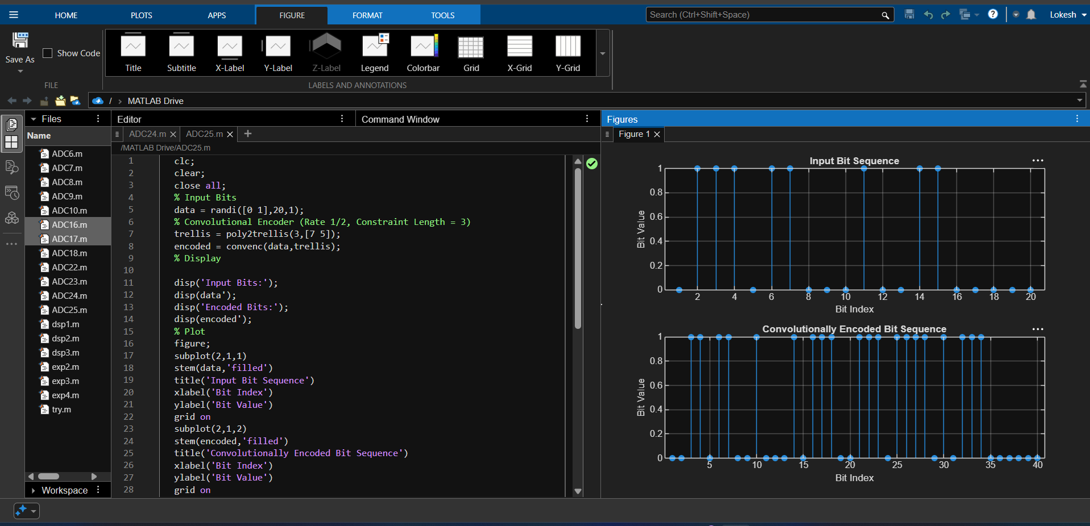
Figure 1: MATLAB code and plotted input and convolutionally encoded bit sequences.
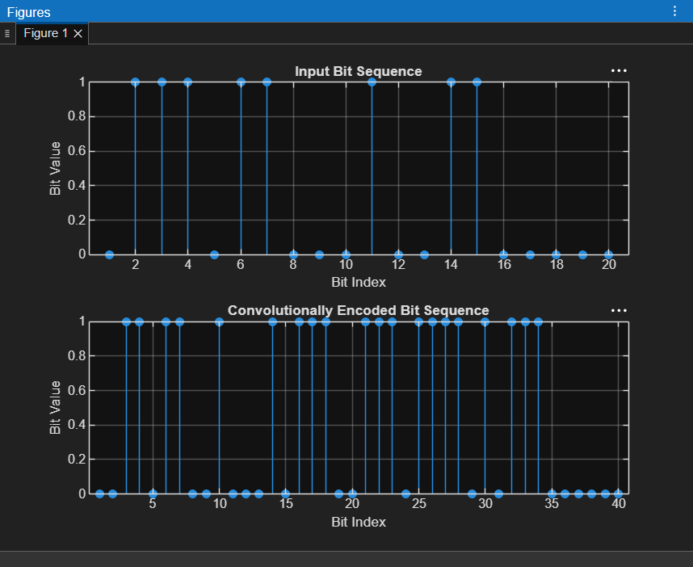
Figure 2: Input bit sequence and convolutionally encoded output sequence.
4. Simulation Parameters
Parameter | Value
Input sequence length | 20 bits
Input bit values | Random binary values: 0 or 1
Encoder type | Convolutional encoder
Code rate | 1/2
Constraint length | 3
Generator polynomials | [7 5] in octal notation
MATLAB functions | poly2trellis, convenc
5. Applications
- Forward error correction in digital communication systems.
- Improving reliability of data transmission over noisy channels.
- Encoding data for wireless and mobile communication links.
- Studying the relationship between input bits and coded output sequences.
6. Procedure
- Generate a 20-bit random binary sequence using randi.
- Create a trellis structure using poly2trellis(3,[7 5]).
- Encode the input data using convenc.
- Display the input bits and encoded bits in the MATLAB Command Window.
- Plot both sequences using stem plots and label the axes.
7. Result and Discussion
The input binary sequence was generated and processed by the convolutional encoder. The plotted output demonstrates how the encoder maps the input bits into a longer coded sequence according to the selected rate 1/2 code and generator polynomials. The random input sequence and corresponding encoded values can change on each run.
8. Conclusion
Convolutional encoding was simulated successfully in MATLAB using a rate 1/2 encoder with constraint length 3 and generator polynomials [7 5]. The input and encoded bit sequences were displayed and plotted, illustrating the basic operation of convolutional coding for error-control applications.
DONE BY
Lokesh A
Register Number: 192512293
B.E. Electronics and Communication Engineering (ECE)

